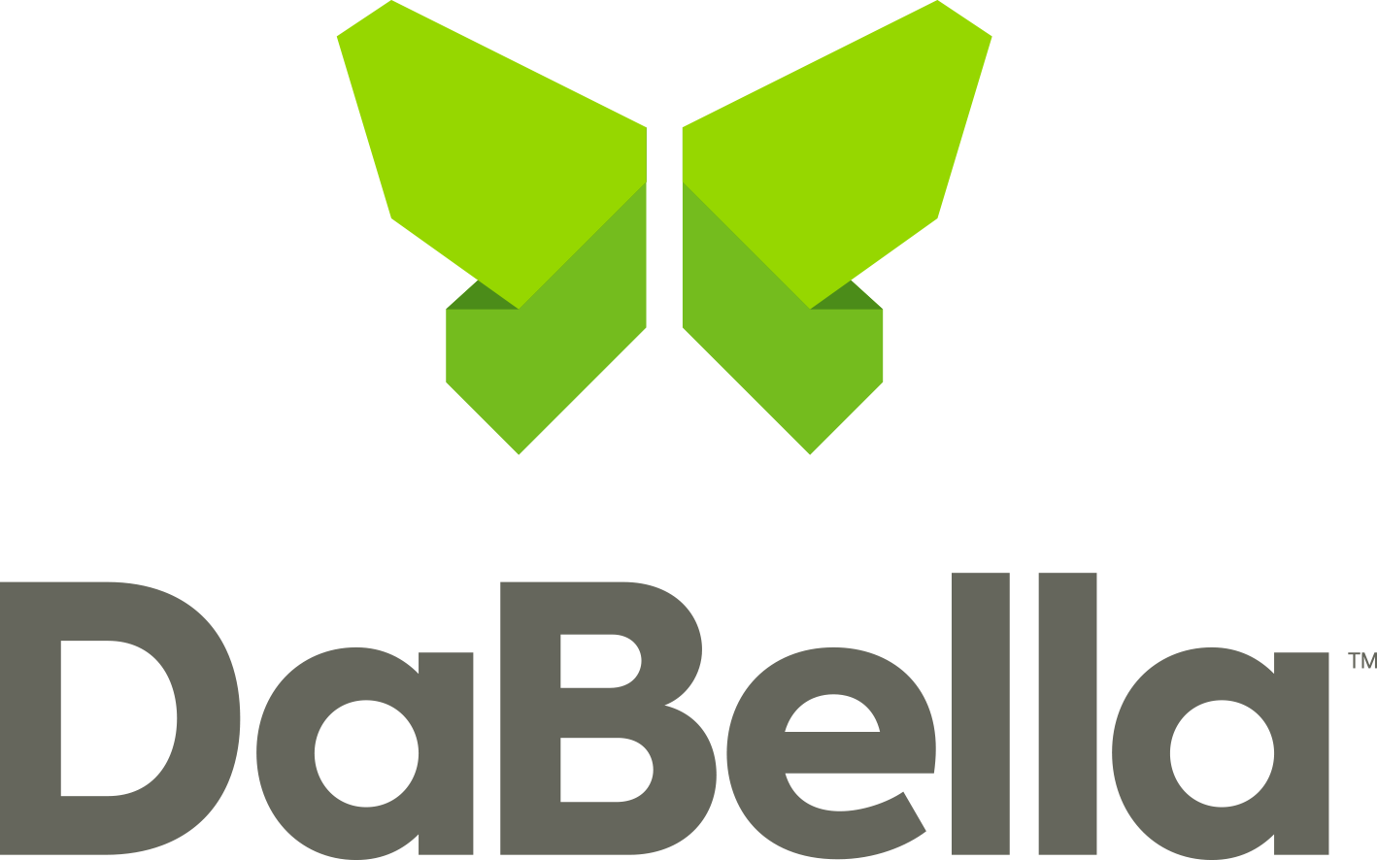

**For Immediate Release**

November 1, 2023

**DaBella Raises $173,000 For the National Breast Cancer Foundation**

Austin, TX

DaBella, a leading provider of home improvement services, raised $173,000 in October 2023 during Breast Cancer Awareness Month. The company reached this milestone through a variety of initiatives, including financial contributions related to customer appointments, internal fundraising with employee participation, and proceeds from the sale of branded merchandise.

DaBella will be allocating 100% of these funds to the [National Breast Cancer Foundation](https://www.nationalbreastcancer.org/), which provides help and inspires hope to those affected by breast cancer through early detection, education, and support services. NBCF has provided over 1.7 million breast health resources to women across the country and holds a four-star rating from Charity Navigator. Breast cancer death rates declined 40% from 1989 to 2016 and this progress is attributed to improvements in early detection, [per the American Cancer Society](https://pressroom.cancer.org/Statistics2019#:~:text=The%20death%20rate%20for%20female,51%25%20from%201993%20to%202016.).

“Every day, the team at DaBella works together to improve the homes of Americans. That teamwork is personified with this initiative, as with teamwork to prevent and support those with breast cancer,” said Bastian Cowsert, Chief Marketing Officer at [DaBella.](https://dabella.us) “DaBella has raised funds related to breast cancer in previous years and 2023 was our most successful program to date. Being able to contribute to the vital work of this NBCF is something we look forward to and will continue to support”.

**About DaBella**

With headquarters in Texas, Oregon, and branch locations in 46 cities throughout the United States, [DaBella is a values-focused home improvement compan](https://dabella.us/dabella/)y that works to improve the quality of life for homeowners nationwide. DaBella employs thousands of Americans and utilizes products from American-based companies. Providing an award-winning experience and the recipient of accolades from *Angi* (formerly *Angi’s List)* and *Home Advisor*, with DaBella, quality begins at home.

Contact: [press@dabella.us](mailto:press@dabella.us)