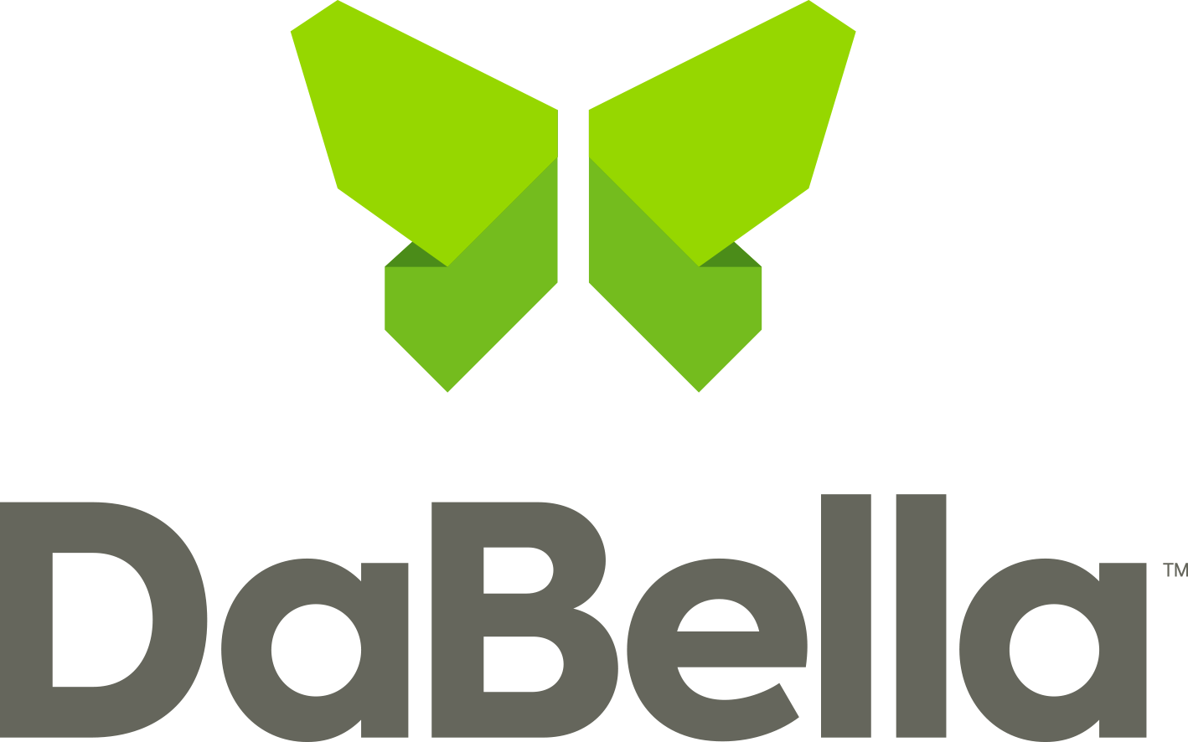

For Immediate Release

September 27, 2023

DaBella and Habitat for Humanity Facilitates Affordable Housing

Dallas, TX

Habitat for Humanity Dallas received a $1000 donation from DaBella, a leading, nationwide home improvement company, to support the organization’s ongoing efforts to facilitate affordable housing and prevent homelessness for residents in the Dallas, TX area.
Habitat for Humanity Dallas is a nonprofit organization dedicated to building homes, communities, and hope for families in need. By mobilizing volunteers, community partners, and donors, they transform lives and provide affordable homeownership opportunities. “DaBella is a terrific partner for Habitat of Humanity, Dallas,” said Jim Campbell, Director of Corporate Giving. “With the donation from DaBella, we’ll continue building new homes to help the community” he continued.
“I’ve built homes with Habitat for Humanity and being part of a company that continues to give back is important,” said Sondra Ferrigno, Customer Service Manager at DaBella. “We care for people and care for homes and contributing to the local community is the DNA of our company,” she said.
With headquarters in Texas, Oregon, and 45 cities throughout the United States, DaBella is a values-focused home improvement company that works to create value for homeowners nationwide. DaBella uses quality-made products while providing five-star customer service. With DaBella, quality begins at home.

Contact: press@dabella.us

